****Московский государственный технический университет им. Н.Э. Баумана  
Кафедра «Системы обработки информации и управления»

Лабораторная работа №6  
по дисциплине  
«Методы машинного обучения»  
на тему

# «Обучение на основе глубоких Q-сетей»

Выполнил:  
студент группы ИУ5-23М  
Чжэн Сяохуэй

Москва — 2024 г.

**1. Цель лабораторной работы**

ознакомление с базовыми методами обучения с подкреплением на основе глубоких Q-сетей.

**2. Задание**

* На основе рассмотренных на лекции примеров реализуйте алгоритм DQN.
* В качестве среды можно использовать классические среды (в этом случае используется полносвязная архитектура нейронной сети).
* В качестве среды можно использовать игры Atari (в этом случае используется сверточная архитектура нейронной сети).
* **В случае реализации среды на основе сверточной архитектуры нейронной сети +1 балл за экзамен.**

**3. текст программы**

Моя среда реализована на основе архитектуры сверточной нейронной сети.

import gym

import math

import random

import matplotlib

import matplotlib.pyplot as plt

from collections import namedtuple, deque

from itertools import count

import torch

import torch.nn as nn

import torch.optim as optim

import torch.nn.functional as F

# 名称环境

CONST_ENV_NAME = 'CartPole-v1'

# 使用GPU

CONST_DEVICE = torch.device("cuda" if torch.cuda.is_available() else "cpu")

# CONST_DEVICE = torch.device("cpu")

# ReplayMemory元素定义

Transition = namedtuple('Transition', ('state', 'action', 'next_state', 'reward'))

# 实现ReplayMemory技术

class ReplayMemory(object):

def __init__(self, capacity):

self.memory = deque([], maxlen=capacity)

def push(self, *args):

'''保存数据到ReplayMemory'''

self.memory.append(Transition(*args))

def sample(self, batch_size):

'''随机选取batch_size大小的样本'''

return random.sample(self.memory, batch_size)

def __len__(self):

return len(self.memory)

# 基于卷积神经网络的DQN模型

class DQN_Model(nn.Module):

def __init__(self, h, w, outputs):

super(DQN_Model, self).__init__()

self.conv1 = nn.Conv2d(3, 32, kernel_size=8, stride=4)

self.conv2 = nn.Conv2d(32, 64, kernel_size=4, stride=2)

self.conv3 = nn.Conv2d(64, 64, kernel_size=3, stride=1)

self.fc1 = nn.Linear(self._calculate_conv_output(h, w), 512)

self.fc2 = nn.Linear(512, outputs)

def _calculate_conv_output(self, h, w):

# 计算卷积层输出大小的函数

def conv2d_size_out(size, kernel_size=3, stride=1):

return (size - (kernel_size - 1) - 1) // stride + 1

convw = conv2d_size_out(conv2d_size_out(conv2d_size_out(w, 8, 4), 4, 2), 3, 1)

convh = conv2d_size_out(conv2d_size_out(conv2d_size_out(h, 8, 4), 4, 2), 3, 1)

return convw * convh * 64

def forward(self, x):

x = F.relu(self.conv1(x))

x = F.relu(self.conv2(x))

x = F.relu(self.conv3(x))

x = F.relu(self.fc1(x.view(x.size(0), -1)))

return self.fc2(x)

class DQN_Agent:

def __init__(self, env, BATCH_SIZE=128, GAMMA=0.99, EPS_START=0.9, EPS_END=0.05, EPS_DECAY=1000, TAU=0.005, LR=1e-4):

self.env = env

self.n_actions = env.action_space.n

state, _ = self.env.reset()

init_screen = self.get_screen()

_, _, screen_height, screen_width = init_screen.shape

self.policy_net = DQN_Model(screen_height, screen_width, self.n_actions).to(CONST_DEVICE)

self.target_net = DQN_Model(screen_height, screen_width, self.n_actions).to(CONST_DEVICE)

self.target_net.load_state_dict(self.policy_net.state_dict())

self.optimizer = optim.AdamW(self.policy_net.parameters(), lr=LR, amsgrad=True)

self.memory = ReplayMemory(10000)

self.steps_done = 0

self.episode_durations = []

self.BATCH_SIZE = BATCH_SIZE

self.GAMMA = GAMMA

self.EPS_START = EPS_START

self.EPS_END = EPS_END

self.EPS_DECAY = EPS_DECAY

self.TAU = TAU

def get_screen(self):

# 从环境中获取当前状态

screen = self.env.render()

screen = torch.tensor(screen, dtype=torch.float32).permute(2, 0, 1) # 调整通道顺序

return screen.unsqueeze(0).to(CONST_DEVICE)

def select_action(self, state):

sample = random.random()

eps_threshold = self.EPS_END + (self.EPS_START - self.EPS_END) * math.exp(-1. * self.steps_done / self.EPS_DECAY)

self.steps_done += 1

if sample > eps_threshold:

with torch.no_grad():

return self.policy_net(state).max(1)[1].view(1, 1)

else:

return torch.tensor([[random.randrange(self.n_actions)]], device=CONST_DEVICE, dtype=torch.long)

def plot_durations(self, show_result=False):

plt.figure(1)

durations_t = torch.tensor(self.episode_durations, dtype=torch.float)

if show_result:

plt.title('resoult')

else:

plt.clf()

plt.title('trining...')

plt.xlabel('Episode')

plt.ylabel('Duration')

plt.plot(durations_t.numpy())

plt.pause(0.001)

def optimize_model(self):

if len(self.memory) < self.BATCH_SIZE:

return

transitions = self.memory.sample(self.BATCH_SIZE)

batch = Transition(*zip(*transitions))

non_final_mask = torch.tensor(tuple(map(lambda s: s is not None, batch.next_state)), device=CONST_DEVICE, dtype=torch.bool)

non_final_next_states = torch.cat([s for s in batch.next_state if s is not None])

state_batch = torch.cat(batch.state)

action_batch = torch.cat(batch.action)

reward_batch = torch.cat(batch.reward)

state_action_values = self.policy_net(state_batch).gather(1, action_batch)

next_state_values = torch.zeros(self.BATCH_SIZE, device=CONST_DEVICE)

with torch.no_grad():

next_state_values[non_final_mask] = self.target_net(non_final_next_states).max(1)[0]

expected_state_action_values = (next_state_values * self.GAMMA) + reward_batch

criterion = nn.SmoothL1Loss()

loss = criterion(state_action_values, expected_state_action_values.unsqueeze(1))

self.optimizer.zero_grad()

loss.backward()

torch.nn.utils.clip_grad_value_(self.policy_net.parameters(), 100)

self.optimizer.step()

def play_agent(self):

env2 = gym.make(CONST_ENV_NAME, render_mode='human')

state = env2.reset()[0]

state = self.get_screen()

done = False

res = []

while not done:

action = self.select_action(state)

action = action.item()

observation, reward, terminated, truncated, _ = env2.step(action)

env2.render()

res.append((action, reward))

if terminated:

next_state = None

else:

next_state = self.get_screen()

state = next_state

if terminated or truncated:

done = True

print('Episode data: ', res)

def learn(self):

num_episodes = 200 if torch.cuda.is_available() else 50

for i_episode in range(num_episodes):

self.env.reset()

state = self.get_screen()

for t in count():

action = self.select_action(state)

observation, reward, terminated, truncated, _ = self.env.step(action.item())

reward = torch.tensor([reward], device=CONST_DEVICE)

done = terminated or truncated

next_state = None if terminated else self.get_screen()

self.memory.push(state, action, next_state, reward)

state = next_state

self.optimize_model()

target_net_state_dict = self.target_net.state_dict()

policy_net_state_dict = self.policy_net.state_dict()

for key in policy_net_state_dict:

target_net_state_dict[key] = policy_net_state_dict[key] * self.TAU + target_net_state_dict[key] * (1 - self.TAU)

self.target_net.load_state_dict(target_net_state_dict)

if done:

self.episode_durations.append(t + 1)

self.plot_durations()

break

def main():

env = gym.make(CONST_ENV_NAME, render_mode='rgb_array')

agent = DQN_Agent(env)

agent.learn()

agent.play_agent()

if __name__ == '__main__':

main()

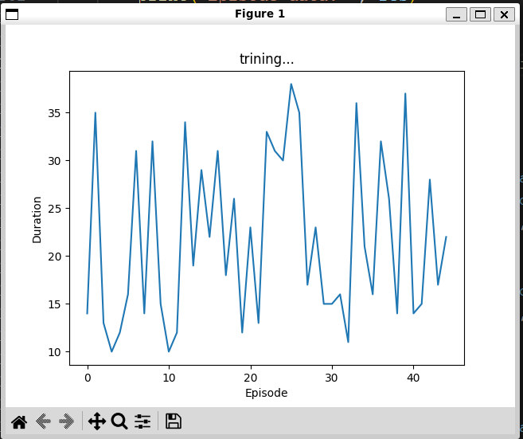4. экранные формы с примерами выполнения программы.

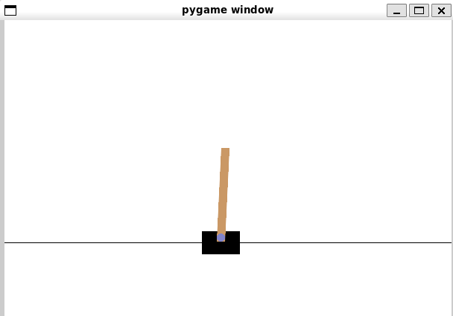

**Список литературы**

[1] Гапанюк Ю. Е. COURSE_MMO_SPRING_2024// GitHub. –– 2024. –– Режим доступа: https://github.com/ugapanyuk/courses_current/wiki/COURSE_MMO_SPRING_2024

[2] <https://www.kaggle.com/datasets>